Student Name：**Jiachen Luo (001061582) Hongyao Tao(001067209)**

**INFO 6205**

**Program Structure & Algorithms**

**Spring 2021**

**Final Team Project**

**Task:**

Understand how to do simulations and draw conclusions from observations. Describe the worst-case growth of any algorithms. Compare at least two viruses with different k/R factors. Provide unit tests for all formulas. Defined parameters via a configuration file.

**Complexity:**

P: the number of people.

S: social distance. Such as 2 meters.

W: grid width. The simulation map will be divided into finite grids by grid width such as 0.5 meter.

B: the number of building.

R: the number of road area. In the simulation, roads will be divided by different blocks. For example, a strait west-east road can be regard as a road area.

V: the number of virus in simulation. An infected person has a virus.

D: infected distance. People may be infected when they stand within this distance. Such as 2 meters.

A: the number of people that virus found within a specific radius.

$$Simulation complexity = O\left(\frac{PS}{W}\right)+O\left(R+B\right)+O\left(\frac{VD}{W}\right)+O(V*A)$$

$$Simulation complexity = People movement complexity + Virus infection complexity$$

$$People movement complexity = Walk + Find a path to building$$

$$Virus infection complexity = Find closed people + Infect$$

Worst case can be happened when all the people are infected and all the people are whin a virus infected distance for each one, which means V = P and A = P.

$$Worst = O\left(\frac{PS}{W}\right)+O\left(R+B\right)+O\left(\frac{PD}{W}\right)+O(P^{2})$$

* Walk

Every people will randomly walk in a building area except when they sleep and eat. As this is simulation project, the most time cost is simulating people walking, which will be increased with the growth of people. Most of time, people will keep the social distance when they walk. The calculation of keeping social distance is implemented by breadth first search O(V).

$$T(BFS)=O\left(V\right)=2(\frac{S}{W}+1)\frac{S}{W}$$

$$T\left(Walk Time Complexity\right)=P+P*T\left(BFS\right)=O(\frac{PS}{W})$$

* Find path to buildings

For simulating the actions of people, people will be designed to walk to school, office, park, mall, restaurant, house. To figure out this problem, the breadth first search also be used.

$$T\left(BFS\right)=O\left(V\right)=O(R+B)$$

* Find closed people

As well as the judgement of whether the next location is still kept with social distance, the problems of that virus find next people for infect can be figured by the breadth first search.

$$T(BFS)=O\left(V\right)=2(\frac{D}{W}+1)\frac{D}{W}$$

$$T\left(Find People\right)=V+V*T\left(BFS\right)=O(\frac{VD}{W})$$

* Infect

This simulation designs many factors to calculate whether the virus can infect the next people. N95 mask will have better protection from the virus than the surgical mask. Furthermore, the virus-infected rate, vaccine efficacy, and distance will also influence the infection judgment. For example, after calculating the finite infected rate considering the mask, vaccine, and distance factors, the simulation program will roll a random number if the number is less than the rate than the person will be infected. If the number is greater than the rate then the person is intact. All the operations will be increased by the growth of virus.

$$T(infect)=O(V*A)$$

**Invariants:**

* Breadth first search

In this simulation, breadth first search is frequently used to figure out problems when people judge the social distance, find a path and virus find the next person to infect. BFS not only search a way that connected two position but also can be perfectly applied to a situation that virus cannot infect the person if there is a barrier, such as showing in P1 graph blow. The invariants of BFS is that there is always an relationship, if A connect B, B connect C, then A connect C.

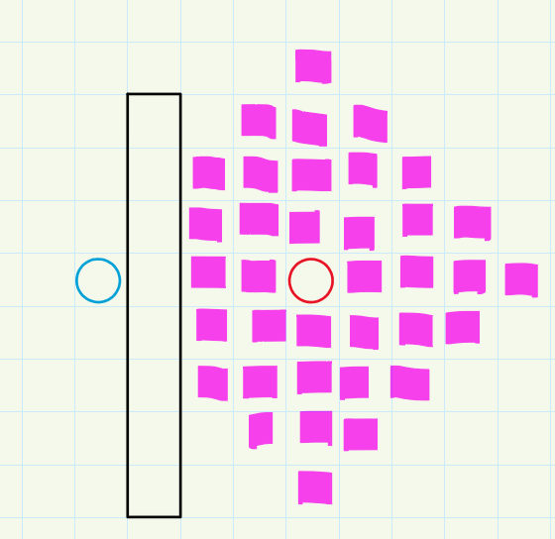

P1. BFS graph

* Walkable area

To constrain a person just random walk within in a specific area such as school, office, home, it needs to find an algorithm that can judge whether people walk in the forbid area. A quick-find algorithm can be used for calculating whether two places are connected. Thus, when people get to the next location by random, we can judge whether the next location is the same as the area of the current location. If they are the same then allow people to move. If not then get another location randomly until they are in the same area, which can limit people just walk in the same area. The invariant for this algorithm is that two locations have the same area.

**Entropy:**

This simulation simulates 26 people in a 40 x 80 meters map. The grids width is 0.5, so the amount of positions are 40 x 80 x 4 = 12800. Since these 26 people can stand in every position, at one time the map can show one situation of ${12800}^{26}$. Otherwise, People have two different situations, being infected and not being infected, so the all infect situations for 26 people are $2^{26}$. To sum up, the entropy is $\log_{2}{(12800}^{26}*2^{26})≈214.64$

**Output (GUI):**

The GUI interface of the project is shown in the figure. The statistic option can draw a statistical graph to describe the relationship between k-factor and time. Setting option can change the basic parameters. It can also display the system time in the model and the details of the number of infected people.

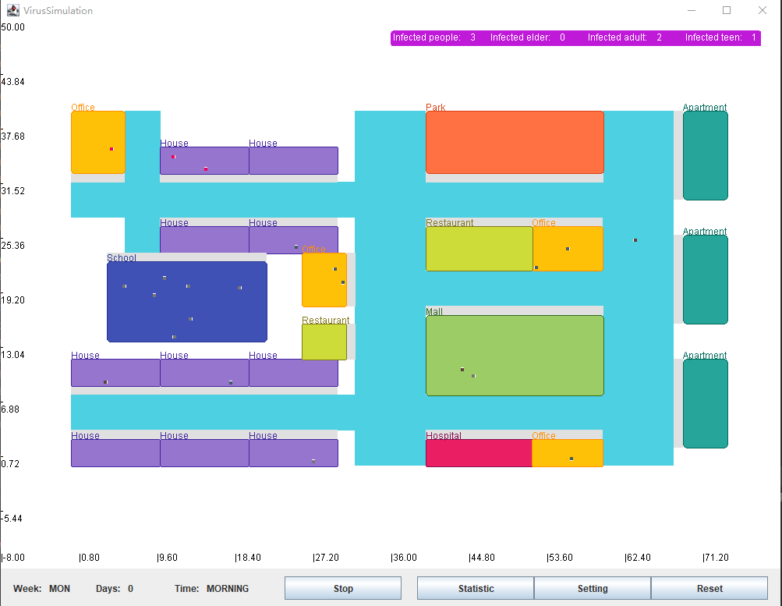

P1. GUI interface

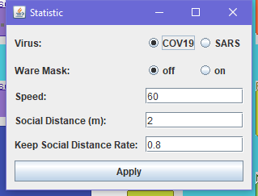

P2. Setting interface

**Graphical representation:**

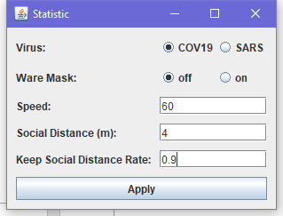

P3. Conclusion 1.1

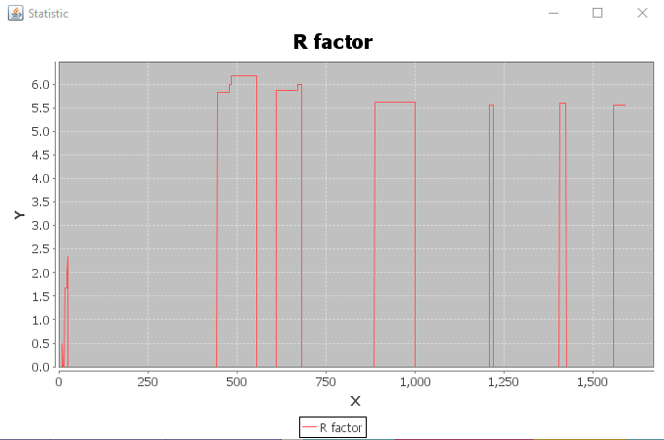

P4. Conclusion 1.2

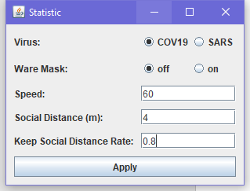

P5.Conclusion 1.3

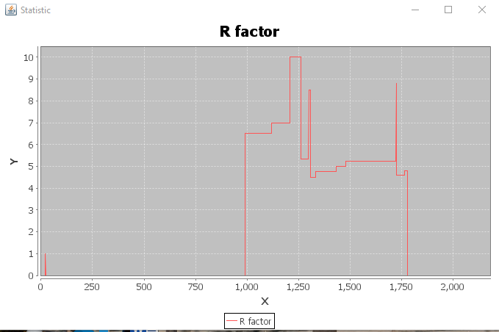

P6. Conclusion 1.4

It can be seen from the two sets of pictures that when people move faster, social distance is closer and keep social distance rate less frequently, the value of k-factor is larger and the infection rate is higher.



P7. Conclusion 2.1

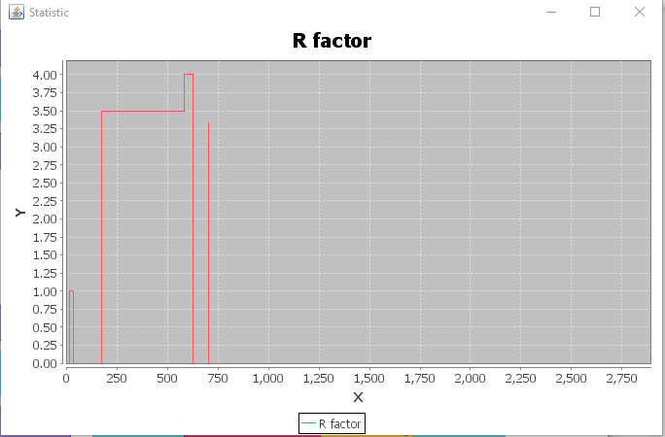

P8. Conclusion 2.2

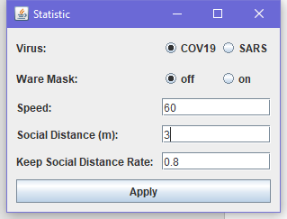

P9. Conclusion 2.1

The statistical table in the second conclusion comes from the same set of data. The reason for the different results is that the infected people are all gathered in a certain office on the map and have not moved to other buildings for a long time, so it can be noticed that the factor (infection rate) drops to 0 at the end of P8. On the contrary, P7 had a very high infection rate during a certain period, because pathogens entered the school (the largest building on the map while maintaining the highest population). Hence it is necessary to isolate the infected people.



P10. Conclusion3.1

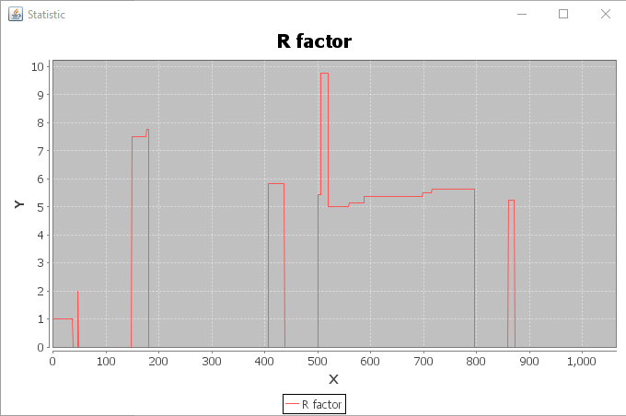

P11. Conclusion3.2

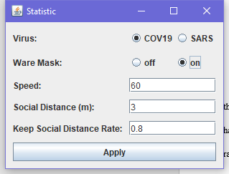

P12. Conclusion3.3

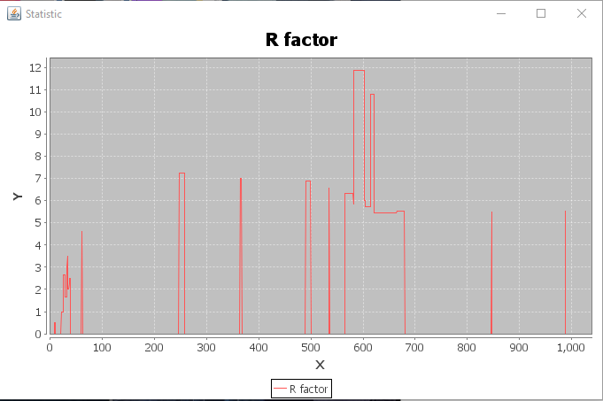

P13. Conclusion3.4

Through the above two sets of pictures, it can be concluded that the infection rate in the same time period is lower when wearing a mask.

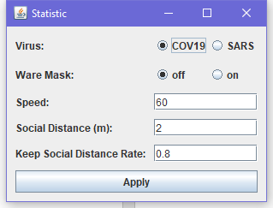

P14. Conclusion4.1

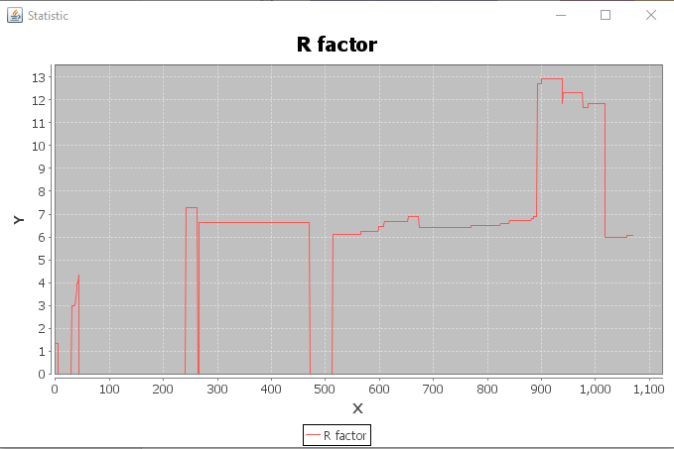

P15. Conclusion4.2

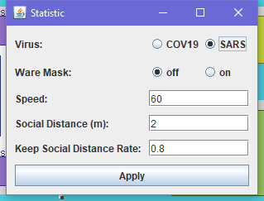

P16. Conclusion4.3

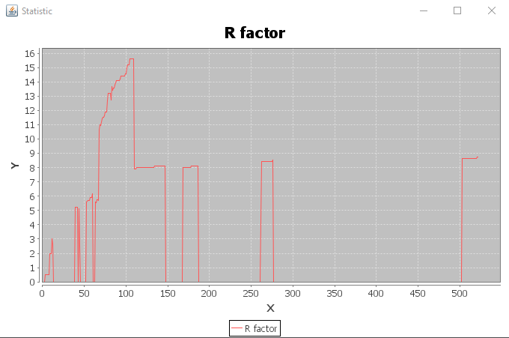

P17. Conclusion4.4

It can be seen that under the same conditions, the SARS infection rate is lower than COVID-19 as SARS cannot contact more people with the high dead rate.

**Unit tests result:**

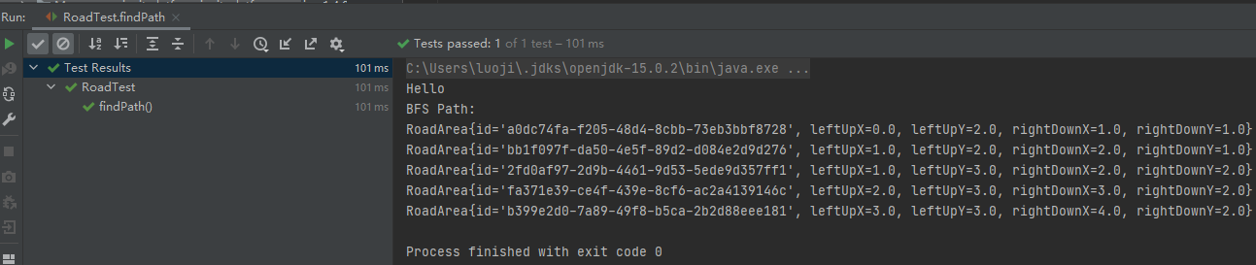

P18. Unit tests of BFS finding a path

**Conclusion:**

After testing the model many times by changing the basic parameters, we can get the conclusion that in order to reduce the probability of virus infection, we need to reduce the number of times we go out and keep a safe distance from other people as much as possible when we go out. Areas need to be isolated and protected.